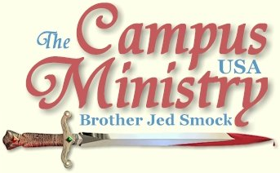
brojed.org
brojed@aol.com
cell 573-999-0347
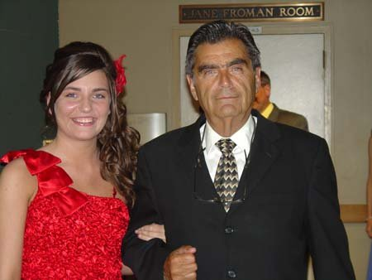
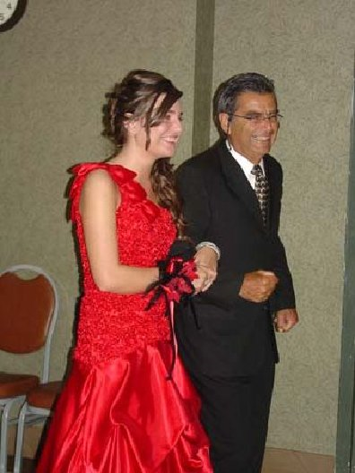
Martha and Dad, Senior March at Elegant Evening
Martha’s Senior Concert
May 13 2010,
Martha played her saxophone and the piano for a gathering of 53 friends and family. When I introduced Martha I remarked that I
graduated from Glenn High School 50 years ago. I had no talent to showcase. Shamefully, I was already a drunkard and of very
poor character. Martha on the other hand not only had her musical talents to exhibit but our family room was filled with projects
and displays including ribbons and awards from her years of home schooling. I commended Martha for never rebelling and
honoring her parents. Dishonoring my parents is my greatest regret from my past life. Martha is a winner because she knows
Jesus. I was a loser because I rejected the Lord in my youth.

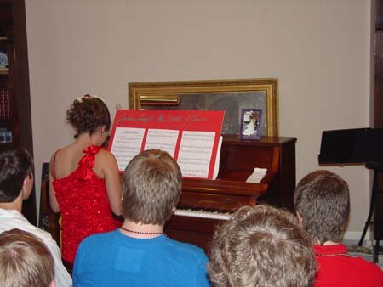
Martha Plays Joshua Fought the Battle of Jericho at Her Senior Concert
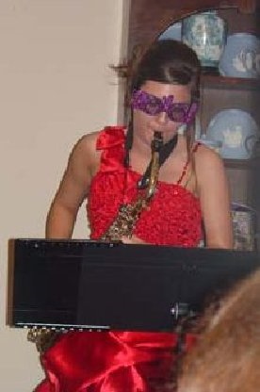
Martha Plays with her 2010 Glasses
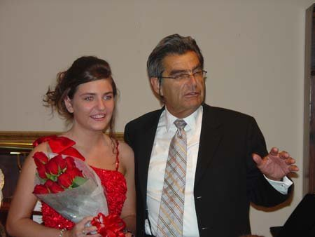
Dad Gives Martha Roses
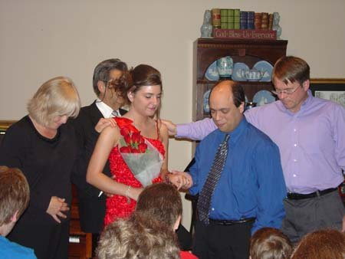
Martha's Music Teachers Pray for Her Future

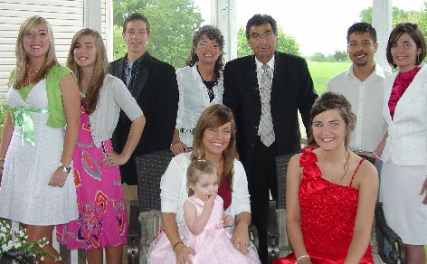
The Whole Family Was Together for the First Time in Over Two Years
Left To Right: Charlotte Smock, Priscilla Smock, Tyler Hughey, Cindy, Jed, David McKay, Evangeline McKay, Justina Hughey, Martha Smock, Iris Hughey

Martha Marie Smock Graduates
May 15, 2010
At a graduation ceremony of the Mid-Missouri Co-Op of Home Educators Cindy and I presented a diploma to Martha. Martha
played “Bring Him Home” from Les Miserables on the saxophone. Priscilla, who completed her sophomore year, was the
accompanist for the prelude and played “Pomp & Circumstance” during the Processional and Recessional. Cindy deserves much of
the credit for Martha’s success.

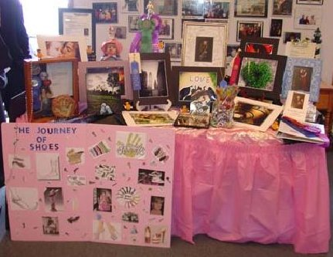
Some of Martha's Displays
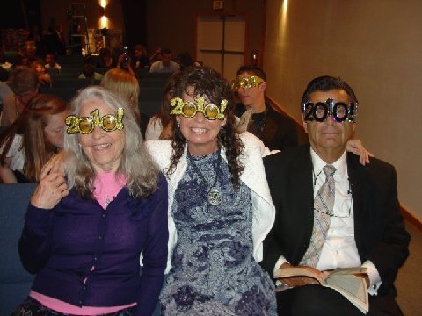
Waiting For the Ceremony to Begin

Martha's Graduation Processional
Below is the biography that I wrote for Martha’s graduation program.
Martha Marie Smock, our fourth daughter, was born at home with the help of a mid wife. I named her Martha after my paternal grandmother who was known as “Mattie.” Mattie was a godly woman and a Bible scholar who was mentally alert until she was 102. Cindy’s maternal grandmother was named Marie. We also liked the connection of Martha and Mary of Bethany. Martha was known for her much serving and Mary for hearing Jesus’ word. We wanted our Martha to have the best qualities of both these sisters, and she does.
Martha has always been fun loving and cheerful. From the beginning Martha was different from our first three girls. She was more rambunctious, liked to make funny faces and made fun of her dad by wiping off his kisses. We were not a pet orientated family but Martha loved animals and always wanted to have a dog. Each Christmas and birthday she would pray that she would get a dog. Finally, Dad gave in and got her a puppy, Gypsy, for her 11th birthday.
One of the advantages of home schooling is that it strengthens the family. Martha is close friends with all four of her sisters and best friends with Priscilla whom she roomed with most of her childhood.
Martha has blessed our home with the sound of music. She faithfully learned the piano and saxophone and more importantly she enjoys playing these instruments.
What I appreciate most about Martha is her ability to make friends with people of all ages. This has been an asset in many areas of her life, but especially in our campus ministry. From the time that she could talk, Martha captivated college students and witnessed for Jesus. She has toured the USA with the family mission to reach students with the Gospel. Next year Martha will assist her Dad in preaching on campuses. Her duties will include photographer, videographer and web master. Her future plans include photography/graphic design school.
Dad’s prayer is that God’s grace will be upon her to defend the faith that was once delivered unto the saints and that like her namesake she will have a long and healthy life.
Martha's Poem
Martha took a poetry class with eight other homeschoolers this year. Below is a poem that she wrote for class:
My Dad Was Once a Hippie
By Martha Smock 5/1/10 Poetry Class

My Dad was once a hippie
Of alcohol he took a sippy
But now he preaches everywhere, even in Mississippi!

Of pot he had a lot
But Christianity he then sought.
My Dad was once a hippie.

He use to streak the beach
Until an Arab came to preach.
So now dad teaches everywhere, even in Mississippi!

He went to preach at Florida State.
And my mom thought he was great.
My Dad was once a hippie.

Now they are both saved
And the college campuses they have braved.
Now my Dad preaches everywhere, even in Mississippi!

God gave them five daughters, YIPPIE!
On campus we witnessed and prayed
My dad was once a hippie.
But now he preaches everywhere, even in Mississippi

FINNEY’S OLD STOMPING GROUNDS
Oberlin College, May 10, 2010
I started preaching a half block down the street from Finney Chapel on the public sidewalk. I was just a block away from Charles Finney’s
pulpit at the Congregationalist Church. When I think of the sacrifices Oberlin’s founders and professors like Mahan and Finney made to
establish a Christian institution to promote revival, it grieves me no end not to have heard one student professing faith in Biblical Christianity and many even defending wickedness, all in the name of love.
I immediately drew three people by holding up my sign which condemns certain sins prevalent on campus. Gradually, the crowd grew until by 2
PM shortly before Bro Cope arrived I had about 50 students. Mr. and Mrs. Mark S., who live in the area, also came out to listen. Mark used to
hear me as an undergraduate at Ohio University back in eighties. Mark was inspired to do some preaching on the streets of Athens during his
time there.
Oberlin is a hotbed of perversion so lesbianism and homosexuality were big issues as was feminism and socialism and other religions. The
students fired one question after another at Bro and me all afternoon. In mid-afternoon I put down the sign face down on the ground. Students
kept asking to see it but I only teased them with the sign showing it only on brief occasions.
I left campus at 6 PM and Bro preached until 7 PM with still almost fifty students listening. Over the years Oberlin has been one of my favorite
campuses to preach upon because of the Finney heritage and also students tend to be bright and actually listen to my answers. They were more
rambunctious today than usual. Students no longer know me here like they did in my Ohio years when I was a regular visitor to Oberlin. Oberlin
is one of the main things I miss about Ohio. Given a few more days I am confident that I could have tamed them considerably.
“UNCONDITIONAL LOVE”
Ohio State, May 11, 2010
This past Sunday I taught the adult Sunday School at the Lutheran church where my hosts attend. The lesson included John 14:23-24, which speaks of God’s abiding love which is conditional. I taught that the expression “God’s unconditional love” is a half truth.
THAT I MIGHT KNOW HIM IN THE FELLOWSHIP OF HIS SUFFERINGS
Ohio State University, May 3, 2010,
I started preaching at 12:20. Four people stopped and listened for a while. There must have been a few hundred sunbathers on the Oval. The girls wore bikinis. They might as well have been naked. I read Romans 2 through 5, while waiting for the next break. At 1 PM I preached an expository sermon on Romans 2:3-11 and Roman 3:9-18. [I read through Romans 11 at other breaks] A PhD in physics interrupted to ask me about grace. So I spoke form Titus 2:11-14. Then I tied it back in with Roman 2:10, “Glory, honor, and peace, to every man that worketh good.” Several listening but they left by 1:30.
Since moving to Missouri, I have not been at OSU that often; few students seemed to know me even though I was for many years a fixture on the Oval. About 1:45 it was called to my attention that another man was preaching on the Oval towards the library, who I had not noticed. I decided to go listen as I waited for the next break.
It turned out to be Cliff Knechtle, who for many years was itinerant on the campuses but in recent years he has pastored back east and only goes to the campuses occasionally. He had too large cameras filming his meeting for a closed circuit TV program. Cliff is a Q & A apologist, who does little if any preaching. But he is good at what he does. He is sponsored by Inter Varsity Christian Fellowship so he had a number of students already gathered when he starts. I think that they are instructed to ask certain basic questions, which gives Cliff the opportunity to make good points. He was rendering death blows to moral relativism for the 15 minutes which I listened.
I returned to the middle of the Oval making sure to be far enough away not to interfere with Cliff. At 2:10 I taught my class in Human Sexuality 101 to the sun worshipers, which explains the basic functions of the bodily organs dealing with sexuality and their proper function and use. It is not proper to flaunt one’s body in public. Many found my class amusing. Six boys gathered with whom I got some dialogue but they left by 2:45. I was getting some attention, but I was not captivating the minds of mush as I usually do.
I had driven 10 hours to get to campus in time to preach. So I was determined not to give up. At 3 PM I tried another location. I even resorted to singing the gay song. I captivated their minds by speaking of genitals. After all, that is where their minds reside much of the time. I rebuked the girls for their immodesty. But they had no sense of shame. I warned against whorish women and one girl said, “Yup, that me.” By 3:30 I had a crowd of about 50. Cliff had stopped speaking. An atheist claimed that he had found contradictions in the Bible but his examples were verses taken out of context or else he interpreted a passage literally which was obviously figurative.
It was a difficult crowd to speak to, since people were spread out on the grass. I really had to project my voice to make myself heard which takes a lot of energy. I gave my testimony and evidences for the existence of God. I engaged a Moslem; after I pointed that the Koran denied the crucifixion of Jesus and his resurrection, I established some common ground with him concerning moral issues, heaven and hell and Judgment Day. He eventually sat down and quietly listened for almost two hours. There was one Jewish homosexual for whom I read Roman 1. I met a man named Bo who is an open theist. He does not believe that the Bible condemns homosexuality; evidently he is influenced by the emerging church.
I ended the day with a strong message on the cross which represents pain, suffering and death. Christianity demands that we embrace the crucified life. Unbelievers want to maximize pleasure and minimize pain. The Cross represents maximum pain. Therefore, sinners want nothing to do with the Cross. Many churches today have embraced Christianity without a Cross, which is no Christianity at all.
Earlier the physics PhD had asked me about John 6. I expounded to him and others on John 6:53, “Verily, verily, I say unto you, Except ye eat of the flesh of the Son of Man, and drink his blood, ye have no life in you.” To eat of his flesh and drink of his blood is to embrace the crucified life. Much of what passes for Christianity is lifeless because it is crossless.
I left campus at 5:30, with sheer perseverance I had redeemed the day and had made my long drive worthwhile. Upon leaving Missouri, I set my face towards Jerusalem with much conflict as to whether I was ready to go on the road again with the pinched nerve. The injury is probably related to a slipped disk. The disk rupture may be linked to some of my old injuries in the line of duty, which makes the pain more meaningful. [I am learning to better manage the pain in the way I sit, move around, use of heating pads and Ibuprofen, etc.]
My philosophy has always been to carry on when attacked with bodily infirmities if I possibly can. So far that practice has served me well. We must press on “for the night is far spent and the day is at hand. Put ye on the Lord Jesus Christ, and make not provision for the flesh.” Paul is speaking in Roman 13:12 and 14 of the lusts of the flesh. But the principle is applicable to the comforts and infirmities of the flesh. With Paul, I can even take a certain pleasure in my aches and pains since I also bear in my body the marks of the Lord Jesus. After complaining Paul accepted his thorn in the flesh for his “strength was made perfect in weakness.” Bodily infirmities help us to identify with the sufferings of Christ and keep our light affliction in perspective.
THE GOLDEN AMPLIFIER
Otterbein University and Ohio State, May 4, 2010
Otterbein is a small private liberal arts college associated with the United Methodist Church. It was named after William Otterbein, itinerate United Brethren preacher. I saw no evidence of true Christianity on campus. Open air preachers are not welcome on college property so I preach on the public sidewalk in front of the Student Union. I reproved, rebuked and exhorted from 12-1, someone was always listening but never over a half dozen at a time. I did get some dialogue going with a professing homosexual and a homophile female who defended sodomy. The sodomite is a United Methodist and he heads a youth group in his church. He was not aware of the fight within Methodism over the churches stand in its book of discipline that “homosexuality is incompatible with Christian teaching.”
Rich Edmonds from Cincinnati joined me at 1 PM. Rich is a pilot, whom I met two years ago, who has also become an open-air preacher. He wore a YOU DESERVE HELL t-shirt. He preached for 15 minutes but by now my audience had left and there were just a few students trickling by so we decided to go to OSU.
There is no where I would rather be on a bright sunny spring day than on the Oval at Ohio State. Like yesterday, there were hundreds of students on the Oval many of them sun bathing. Cliff K. was doing his Q & A again at the library end of the Oval. I started in the middle in a section of the Oval which had had mostly female sunbathers. I got on their case heavily for their flaunting of the flesh and neglect of their spiritual nature. They did not seem disturbed about my preaching except for one female in short shorts who asked me to leave because my “screaming” was bothering her and her friends in their study. I responded that the naked females flaunting their bodies bothered me. If they had the right to be naked, then I had the right to complain about their nakedness. No one came to her defense. The females many of whom were out yesterday kept begging me to sing the gay song. I reluctantly relented. Later another girl personally pleated with me to sing the gay song. She threatened to kiss another girl if I did not sing it. What was I to do? I sang the song. Later another lusty female requested the song. I got her to agree to put on her t-shirt for the rest of the afternoon if I would sing the song. She put on the shirt, but alas, she did not keep her promise; she soon took it off again after I sang. The gay song is quite an attention getter.
Like yesterday there were a lot of students in the area who could hear me; most of them seemed to be listening at times and conversing with their friends at other times. I expect undivided attention; I am not happy when I only have divided attention. I told some of my old stand-by attention getting stories with only limited success. I taught my Human Sexuality course to the amusement of Rich E. Still the heathens’ attention was divided and I was not getting as much feedback I usually get and almost always expect.
Finally around 3:45 I had a break through. Some students gathered around more closely and I captured their undivided attention. There was a group of atheists and also the Jewish homosexual from yesterday. I taught on the Moral Law of God which is compatible with the natural law.
Tom Short asked me what I was doing on May 4, forty years ago, which was the date of the Kent State incident. At that time I was a socialist instructor in history at the University of Wisconsin. I am afraid that two students got what they deserved that day for it was a violent demonstration. The ROTC building had been burned down a few nights before. Unfortunately, two students who were going to class caught stray bullets. The violent protestors were at fault for initiating the fight by throwing rocks at the guardsmen. The guardsmen were upholding the law and decided that they needed to do so with force. After initial demonstrations against the National Guards’ action, a few more demonstrating students were killed at Jackson State. After students realized their lives were on the line if they continued violent demonstrations, most of the nonsense stopped on campus. That generation of protesting students was not only unwilling to fight for their country but they were also unwilling to risk their lives for their anti-war, peace and love views. Many of the students after the Kent State incident said, “We thought they were firing blanks.” Today, they think I am firing blanks, but they will find out differently on the day of wrath and righteous judgment of God.
Rick Edmonds preached twice but he blew out his voice after his first session. So he did not speak long either time. Via phone communication he told me later that he learned a lot by watching me interact with the students. He explained when he preaches he mostly delivers a monologue. No one is better at a monologue than Rush Limbaugh but even Rush interacts with callers. His monologues alone could not carry his program for three hours. I think that Rush would say that the interaction with his radio audience also stimulates his thinking. Rush thinks on his feet, or I should say his chair before the golden microphone. Dialogue and debate stir my thinking process. The good open-air evangelist must be able to think on his feet and speak in an entertaining fashion. Rush has his golden microphone, but I have the golden amplifier. It is the Holy Ghost.
Rich made a good point during his preaching on Hell. He said that he is willing to preach outside and be regarded as a nut or fanatic or fool because he believes that Hell is an actual place of torment. I thought as he was preaching that there are so few open air preachers because even most evangelicals do not really believe in Hell. Oh, they occasionally refer to Hell but not with the great sense of urgency that the doctrine requires. If preachers really believed in Hell, there would be open air preachers everywhere.
The open theist Bo, who I mentioned in yesterday’s journal, took me to dinner in the Student Union. We discussed Hell. Bo is a Universalist who thinks in the end that all will be saved. He also accepts homosexuality. We discussed the atonement. He rejects the penal substitution theory and leans towards the ransom theory. He has been influenced by Greg Boyd. I very much enjoyed the conversation and hope that I gave him a lot to think about. He is considering seminary.
In the evening I attended a Bible Study on Isaiah 55 at my host’s Lutheran church. The chapter is an inspiration to evangelize the world, especially for the promise that God’s Word will not return unto him void. This promise keeps me from discouragement. Cindy preached her first open-air sermon from Is. 55, “Ho, everyone that is thirsty, come ye to the waters. . .” Isa 55 is the Messiah’s invitation to the whole world. God has given the Christ as a witness to the world. Now he is given us open-air preachers as a witness to the nations. And the nations of the world are represented at a great university like OSU. Yesterday, a man from Pakistan listened to me for two hours.
Today, I left my host’s home forgetting my Ibuprohen. I did not notice greater discomfort without it. So maybe it was bobby BIBLE’S cell phone prayer in the morning that made the difference. Certainly prayer is a greater force than pills. With your prayer support I am counting on overcoming this infirmity. I am mostly concerned with keeping up my strength more than a deliverance from the malady. So far by the spirit of God, whose anointing daily breaks the yoke, the Lord is enabling me to sail on. But with your prayer support I am still counting on a complete deliverance so that I can get back to my exercise routine with some recommended modifications.
THE VILENESS, REPUGNANCY, ABHORRENCE, DESPICABLENESS,
AND LOATHSOMENESS OF SIN AND SINNERS
OSU, May 5, 2010,
There were 1100 backpacks spread on the middle of the Oval. A group of students for suicide prevention had put them out. Each backpack was from a college student who had committed suicide over the period of a year. Some of the packs had notes attached which were written about the self-murderer.
I was stirred in my spirit and cried out, “Suicide is a sin and virtually all of the students represented by a pack are in Hell. Likely, all of them are in Hell. I have no sympathy for these people although I do sympathize with their families for the heartache and shame these murderers brought to their families. To commit suicide is to fire a shot at God. For our bodies are not our own to do with simply as we please. They were designed to be the temple of God. Men do not have the right to take their own life. Judas betrayed Jesus and went out and hanged himself. Murdering oneself is the ultimate act of selfishness. I suspect you will find that a high number of these backpacks were carried by homosexuals. Suicide is a despicable act.”
I continued on this theme, which I thought would get a reaction out of the students, but no one challenged anything I was saying even when I returned to the subject a few times throughout the afternoon.
I built the crowd by getting into an argument with one professing Christian, Michael. He believed that you do not have to tell people that they are sinners since they know that and most will admit to being sinful. He thought that it is sufficient to simply get men to acknowledge they are sinners. I countered that we must convince them that sin is exceedingly sinful and is deserving of eternal damnation. After much exhortation the best that I could get out of Michael is that sin is “pretty bad.” The weakness of the Way of the Master presentation of the law seems only to result in getting men to admit that they are sinners, but the advocates of this method, who I have heard, do not press in the sword deeply enough to pierce the heart of the sinner that he might see that he is a wretched man deserving of the wrath of God and eternal torment, who in Hell will be “an abhorring unto all flesh (Isa 66:24).” The sinner should see himself as abhorrent and loathsome in the sight of God before he is ready for the grace of God. Michael would not even see sin as repugnant and vile, let alone the sinner.
With Michael as my foil I gathered a group around me early which at times reached up to fifty but mostly ranged from 20 to 30. There were also many more sunbathers listening at a distance. Michael walked off a few times but I was able to call him back each time and he ended up staying for a few hours.
Bro arrived around 2 PM and I turned the meeting over to him. We alternated for the rest of the afternoon. I had a dinner engagement in the evening so I left the meeting to Bro at 4:45, who reported to me later that he preached until 7:30. My host, Bill L., came to campus today and held one of my signs. Bill is the husband of Pauline, who was our first convert in Columbus when we moved here in the mid-eighties to establish College Community Church. Pauline turned out to be to us what Lydia was to Paul. Soon after Pauline’s conversion, her son Paul, who was an OSU student at the time, surrendered to Christ and he preached on the campuses himself for several years.
Two other charter members of College Community Church, David Tripp and his wife Denise were on campus today. David was saved out of the Jesus movement and has been a faithful campus preacher for over 25 years. David also took a few turns preaching. Cliff K. was still holding forth at the library end of the Oval. Another preacher, Dwayne, who has occasionally preached on the oval for decades, was speaking mostly to the wind and squirrels on another section of the Oval. He finally came over and got into an argument with several students in the crowd which we had gathered. Dwayne has some bizarre doctrines. Many years ago I had a formal debate with him. Campus Crusade also had a booth on the Oval approaching students with questions concerning the nature of God. The Oval is a big place so there was more than enough room for all of our efforts. It was sunny, windy and in the low 80’s today, a wonderful day to preach. Alas, to most it was just a wonderful day to have fun in the sun.
A regular heckler at OSU going back to the eighties is the one we called, “Harry the Witch,” who is a custodian at OSU. Harry was a persistent heckler for years; he finally made a profession of faith which lasted for several weeks. He even spent some days staying in our home in Newark. But, alas, soon “came the wicked one and snatched away that which was sown in his heart.” He never returned to witch graft; now he calls himself “Harry the Pagan.” Harry likes to brag that he put a curse on me that I would have no sons, only daughters. I sort of go along with it and say that his curse had turned into my blessing.
FILIBUSTERING FOR THE LORD
Ohio University, May 6, 2010,
My host, Bill L., and I drove to Athens; I started preaching on the public sidewalk next to the Civil War Monument. There were several people sitting around the monument and some were eating lunch. They seemed to be ignoring me but I am not easily disregarded. There never seems to be a large passage of students at OU. Tom Short said at dinner last night that sometimes one just has to filibuster until the people come. So I filibustered until two frat boys arrived and I got some dialogue going with them. However, things began to liven up as the gays gathered. They were in good humor. I guess they were trying to live up to what they call themselves. At one time almost half the crowd was professing gayness. One very pretty tall and slim blond, who was sitting with a boy, asked about oral sex. Bill who is 78 was shocked when she asked about this perversion and more shocked when she said she did not believe in God. I obliged perverted ones by singing the gay song by their request twice.
The main issues of the day were socialism vs. capitalism and the American Heritage. I read from the Declaration of Independence. Some claimed that the references to deity in the Declaration do not use God’s name nor does it declare the Christian God. I explained that most of the signers where members in good standing in Christian churches. Therefore, they would have meant the Christian God. I know of no god or gods of other religions which respect the rights of man or is spoken of as “Divine Providence.”
One student, who appeared to be in his mid 20’s, was nodding his head in approval at my preaching. I finally asked if he was a Christian. He affirmed that he was. I invited him to give his testimony. The crowd quietly listened. They also wanted to hear from Bill who was sitting in a lawn chair in the middle of the crowd. He stood up and talked about his relationship with me and spoke of my mission. Bill, always the gentlemen, spoke of how honored he was to be on the OU campus. He is a native of Ohio but had never been to OU. Later a few students came up and conversed with him and he was able to give them a witness.
I preached until 5:30 and limped back to the parking garage to pick up Bill at the monument with the stuff. When I returned, Bill was wearing the colorful sandwich board signs which pictures typical sins of students. Two girls were questioning Bill. Since he is a Lutheran they were asking him what Lutherans believe. They also took his picture wearing the sign which will likely appear on Facebook.
Aaron M. wrote on my Facebook wall today, “I used to sit on the college green and listen to you when I attended OU in 1994-1999. It was always entertaining.”

HELP FROM FRUIT OF MY MINISTRY AT FSU

Ohio State, May 7, 2010,

Friday is a much slower day on the Oval. Soon a few people sat down to listen. One boy was majoring in economics so I addressed capitalism vs. socialism. His solution to social problems was always a governmental solution. My position is that government should not do what men are able to do without the assistance of civil government. He continuously came up with excuses why men could not provide for their own needs. I dramatized the children’s story of “The Little Engine that Could.”

Dr. Patrick J., who as a partying hypocrite at Florida State, heard me preach at his alma mater in the early eighties. As a result, he got saved and started preaching himself. He became a part of College Community Church in Newark, Ohio, while he was practicing medicine in the area. Friday is his day off and he came out to campus with his two sons, James, 8, and Daniel, 6. Patrick did the preaching for the remainder of the day. He held a large picture of an aborted baby which helped gather more students’ attention. Patrick is one of the best debaters that I know. He kept bringing the gainsayers back to the most basic argument for God’s existence, “the impossibility of the contrary.” We preached until 5:30. His boys passed out Chick tracts and held the abortion sign, much to the distress of the bleeding heart liberals. James quoted Psalms and preached on the Day of Judgment.

I had dinner at the J.’s country estate with his wife, and their five other children. Elizabeth is with child number eight. She also became a preacher at FSU while a student and stirred the campus. Afterwards the doctor examined me and diagnosed my problem as Lumbar Radiculopathy, which I understand to be in layman’s term a ruptured disk and pinched nerve. Saturday, he arranged for me to have an X-ray to confirm the diagnoses. He hopes that by prayer and physical therapy I can be healed without surgery. We should know more after the results of the X-ray early next week.

MOTHER’S DAY
March 9, 2010
Charlotte Gelder Smock, 1911-1994: She was the kindest mother a son could have. She taught me to pray. When someone made fun of me, I stopped saying my prayers at her knees at 11 years old. Thereafter, I stopped praying altogether. In my rebellious youth I caused her much heartache. When I was living on a hippy commune in Morocco, she prayed one Sunday after hearing the minister speak from 1 Peter 5:7, “Cast all your cares upon him, for he cares for you.” She testified that that morning she “cast me unto the tender loving care of the Lord.” A short time later my parents received a letter from me requesting a Bible. They sent me a pocket size Gideon’s New Testament, which I had been given in the fifth grade. Reading the Scriptures was the turning point in my coming home to my Heavenly Father and back into a precious relationship with my parents for their remaining years. Mother’s prayers made the difference. People have been mocking my testimony for 38 years, but I preach on. And I look forward to soon joining my mother and father in Heaven where we will never again be separated. Thanks be unto God, who gives us the victory over sin and death through the gospel of our Lord Jesus Christ!
Today, I taught the adult Sunday School at my hosts Lutheran Church on Acts 16:9-15 and John 14:24-29. It caused some lively discussion when I explained in the light of John 14 that there is a conditional aspect to God's love.
This morning I attended a breakfast with eight old men from the Lutheran Church. Today I asked Dave, who is a retired pastor from the church, if he had given any more thought to my teaching on this concept of unconditional love. He informed me that the churches mission statement said the following, “The gospel of Jesus Christ that reveals God's unconditional love for all creation calls us to the same unconditional love.” I did not know that when I was presenting the lesson that I was teaching at least partially against the church’s mission. I did acknowledge to the class that there is an unconditional aspect to God’s love which would be his benevolence for all creation that is the love of John 3:16.
There was a mix up on my application for public access at Columbia State Community College, which I did not get approved in time to preach on that campus. It rained heavily all morning and off and on in the afternoon. We got a break in the clouds by 3:15 so I preached for 15 minutes while holding my sign which lists sins at Ohio State. The grass on the Oval was wet so no one was sitting out. Many passed by and look at my sign but walked on by.
This evening I attended a Bible Study at the Lutheran church. I argued with Dave and Carl who will not accept that Jesus in the only way to God. My host, Bill, sided with me. Multiculturalism and pluralism have taken precedent over the Bible among many in the mainline churches.
May 12, 2010
I stopped at Wright State but when I arrived at the free speech area it started raining. Since I had a long drive to Columbia to return for Martha’s graduation recital, I decided to head home.
Bro. Jed's Health
Brother Jed has been diagnosed with a pinched nerve. It makes it difficult for him to sit or stand. However he has persevered and
has not missed any days on campus because of his illness. Before he left for the Western States he was able to have two chiropractor
treatments. He needs your constant prayers as he preaches on campuses in Washington and Oregon over the next three weeks. Thank You, Sis. Cindy

You may donate to CMUSA by mailing to our home office at 2402 Longview Dr., Columbia, Missouri 65203 or through Pay Pal by going to our web site, brojed.org. Gifts are tax deductible.

